The Muscular System

[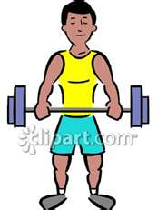](http://www.bing.com/images/search?q=free+clip+art+muscles&view=detail&id=0DD76D4B72C1AD5FEDE7F32DC7877ED5A15A44EE&first=0&FORM=IDFRIR)

FUNCTION OF THE MUSCLES:

Muscles give your body **shape.** They **protect** bones and organs. Muscles hold your body up and give it **support.** Muscles also help you **move.**

How muscles work:

**Muscles work by contracting (pulling).**

**Your muscles work in pairs.** Bend an arm. A muscle pulls your lower arm bones toward your upper arm bone. Straighten your arm. Another muscle pulls the lower arm bones away from the upper bone.

Now feel the inside of your upper arm while you bend your arm. Straighten your arm. Can you feel your muscles working to move your arm?

Place the palm of one of your hands on the underside of your desk while feeling the bicep of that arm with your other hand. Slightly push up against the desk. Do you feel your bicep pull/contract? Now push down on the desk with the back of one hand. Do you feel the triceps pulling/contracting?

[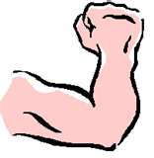](http://www.bing.com/images/search?q=free+clip+art+BICEP+TRICEPT&view=detail&id=BCE36734D1739037A6E939D369F0F079147B2000&first=0&FORM=IDFRIR)

**How Can You Help Your Muscles Develop?**

You do not build strong muscles in a week or in a few months. You build muscles by using them throughout your life.

Exercise - You should be active for at least 60 minutes a day. The pictures show ways you can enjoy building your muscles and keeping them healthy by playing and exercising.

 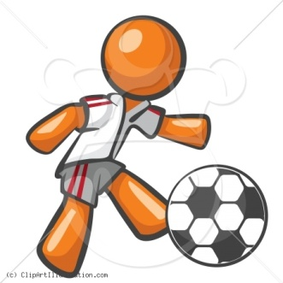 [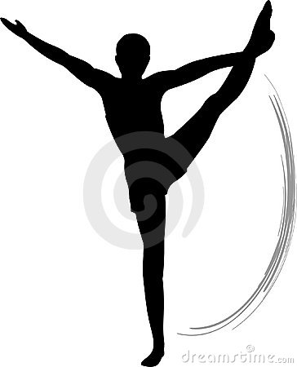](http://www.dreamstime.com/men-s-gymnastics-floor-exercise-thumb3917745.jpg) [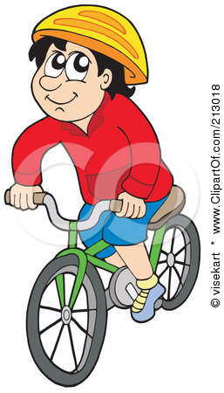](http://images.clipartof.com/small/213018-Royalty-Free-RF-Clipart-Illustration-Of-A-Happy-Boy-Riding-His-Bicycle-And-Wearing-A-Helmet.jpg)

[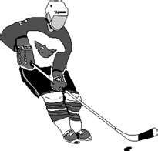](http://www.bing.com/images/search?q=clip+art+free+child+ice+hockey&view=detail&id=3646B792F9EAE73C81B716C8F1059AF7DFF87B06&first=31&FORM=IDFRIR)[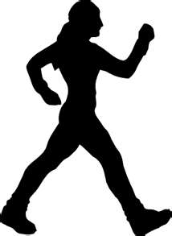](http://www.bing.com/images/search?q=muscle+exercise+clip+art+free&view=detail&id=CD7A4B73BCE18DD73C3140D230C827A58EA0F11B&first=31&FORM=IDFRIR)[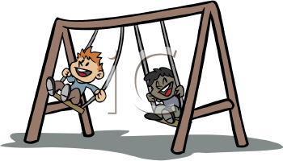](http://www.clipartoday.com/_thumbs/024/kids_playing/kids_playing_012_01_tnb.png)[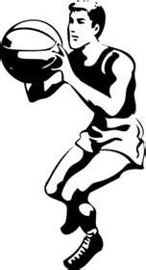](http://www.bing.com/images/search?q=freee+clip+art+child+playing+basketball&view=detail&id=930BF9FD9BEA7FDA7887A0D9A1D0BBB5322CCCA1&first=0&qpvt=freee+clip+art+child+playing+basketball&FORM=IDFRIR)[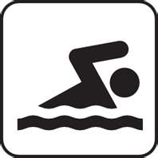](http://www.bing.com/images/search?q=clip+art+free+child+swimming+freestyle&view=detail&id=20459D781BA1772DA31143DB900F6D711BBC726D&first=0&FORM=IDFRIR)[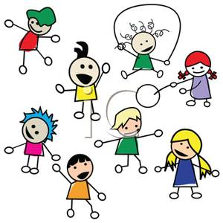](http://www.picturesof.net/_images_300/A_Colorful_Cartoon_Children_Playing_with_a_White_Background_Royalty_Free_Clipart_Picture_100512-010838-919053.jpg)[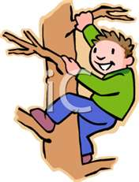](http://www.bing.com/images/search?q=free+clip+art+children+climbing+a+tree&view=detail&id=4F1F761F092CC871F04A2248C59C87811B147E09&first=0)

How many of the activities above do you do? ____________________________.

What is your favorite activity? ________________________________________.

Are you active for 60 minutes a day?___________________________________.

Food AND Diet - Eating the right amount of healthy foods also helps keep your muscles healthy. Your muscles need food to work. Foods rich in protein such as lean meats, fish, eggs, nuts, legumes (beans), and dairy products can help your body work. Fruits, vegetables, and whole grain breads and cereals can also help give you energy and help your muscles work.

**Types of Muscles:**

Your body has **3** different types of muscles:

1. **Skeletal Muscles –** These are the muscles that attach to your bones. **Tendons** attach muscles to bones. When a muscle contracts it pulls on a tendon to move the bone. These are voluntary muscles**.**
2. **Cardiac Muscle –** This is your heart muscle. It works on its own, so it is an example of an involuntary muscle.
3. **Smooth Muscles –** Examples of smooth muscles are your stomach and intestines that help you digest your food. These muscles work own their own, so they are examples of involuntary muscles.

[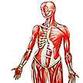](http://www.bing.com/images/search?q=free+clip+art+skeletal+muscle+in+body+&view=detail&id=0C54A329A8343EFB588E6D14CCE0FB52177F2E28&first=0&FORM=IDFRIR)[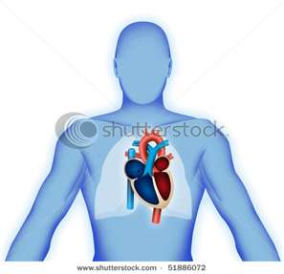](http://www.bing.com/images/search?q=free+clip+art+HEART+IN+BODY&view=detail&id=EC6E4C635657EF1FEA03DB7D72C01868DAFAFF3E&first=0&FORM=IDFRIR)[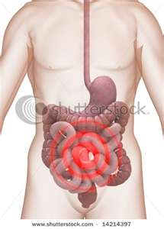](http://www.bing.com/images/search?q=free+clip+art+STOMACH+AND+INTESTINES++IN+BODY&view=detail&id=FB0A585ED2F6B63956081825F614010D64C21373&first=0&FORM=IDFRIR)

**Skeletal Muscles Cardiac Muscles Smooth Muscles**

**Diseases of the Muscular System:**

The following are some diseases that affect the muscles of the human body:

**Multiple Sclerosis** – causes the muscles to “forget” how and when to move.

**Muscular Dystrophy** and **Lou Gehrig Disease** – cause the muscle tissue to break down and weaken.

**Lyme Disease** – a preventable and treatable disease that comes from the bite of a tiny deer tick found in wooded areas. Be careful in areas where ticks are common, particularly April through October. If you are walking in long grass, make sure that your legs and feet are well covered. Have someone check your hair and clothes after playing outdoors. If you have pets, check for ticks on a daily basis. Lyme disease, when caught early is very curable.

[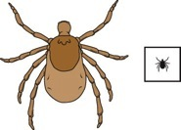](http://www.central-laborers.com/healthier_online/BitesStings_files/deer_tick.jpg)Actual size of a deer tick

**Muscles of the Human Body:**

You have more than 650 muscles in the body. Some of the major muscle groups of the body are listed below.

Insert "Muscles Labeled" Here

Millie Muscle blank worksheet